
Greenwood College

Semester Two Examination, 2018

Question/Answer Booklet

MATHEMATICS APPLICATIONS
UNITS 1 AND 2

Section One:

Calculator-free

Your name

Time allowed for this section
Reading time before commencing work: five minutes
Working time: fifty minutes

Materials required/recommended for this section
To be provided by the supervisor
This Question/Answer booklet
Formula sheet

To be provided by the candidate
Standard items: pens (blue/black preferred), pencils (including coloured), sharpener, correction fluid/tape, eraser, ruler, highlighters

Special items: nil

Important note to candidates
No other items may be taken into the examination room. It is your responsibility to ensure that you do not have any unauthorised material. If you have any unauthorised material with you, hand it to the supervisor before reading any further.

Structure of this paper

Section | Number of questions available | Number of questions to be answered | Working  time (minutes) | Marks available | Percentage of examination
Section One:  Calculator-free | 8 | 8 | 50 | 52 | 35
Section Two:  Calculator-assumed | 13 | 13 | 100 | 98 | 65
 |  |  |  | Total | 100

Markers use only
Question | Maximum | Mark
1 | 5
2 | 5
3 | 7
4 | 8
5 | 6
6 | 7
7 | 6
8 | 8
S1 Total | 52
S1 Wt (×0.6731) | 35%
S2 Wt | 65%
Total | 100%

Instructions to candidates

1. The rules for the conduct of examinations are detailed in the school handbook. Sitting this examination implies that you agree to abide by these rules.

2. Write your answers in this Question/Answer booklet.

3. You must be careful to confine your response to the specific question asked and to follow any instructions that are specified to a particular question.

4. Supplementary pages for the use of planning/continuing your answer to a question
have been provided at the end of this Question/Answer booklet. If you use these pages to continue an answer, indicate at the original answer where the answer is continued, i.e. give the page number.

5. Show all your working clearly. Your working should be in sufficient detail to allow your answers to be checked readily and for marks to be awarded for reasoning. Incorrect answers given without supporting reasoning cannot be allocated any marks. For any question or part question worth more than two marks, valid working or justification is required to receive full marks. If you repeat any question, ensure that you cancel the answer you do not wish to have marked.

6. It is recommended that you do not use pencil, except in diagrams.

7. The Formula sheet is not to be handed in with your Question/Answer booklet.

Section One: Calculator-free 35% (52 Marks)
This section has eight (8) questions. Answer all questions. Write your answers in the spaces provided.

Working time: 50 minutes.

Question 1 (5 marks)
(a) Solve the equation $4\left(5-2x\right)=x-7$ for $x$. (2 marks)

(b) Ash, Billie and Chris collected a total of $160$ cans to recycle. Ash collected twice as many cans as Chris, Chris collected $12$ more cans than Billie and Billie collected $x$ cans.

Determine how many cans Billie collected. (3 marks)

Question 2 (5 marks)
The number of job applications per day received by a company over a period of $16$ consecutive days are listed below:

$$4, 2, 5, 4, 3, 3, 1, 2, 4, 3, 3, 3, 2, 4, 4, 3.$$

(a) Determine the five-number summary for this data. (3 marks)

(b) Use the five-number summary to construct a box-plot on the scale below. (2 marks)

Question 3 (7 marks)
(a) The graph of $y=ax+b$ is shown below. Determine the values of $a$ and $b$. (2 marks)

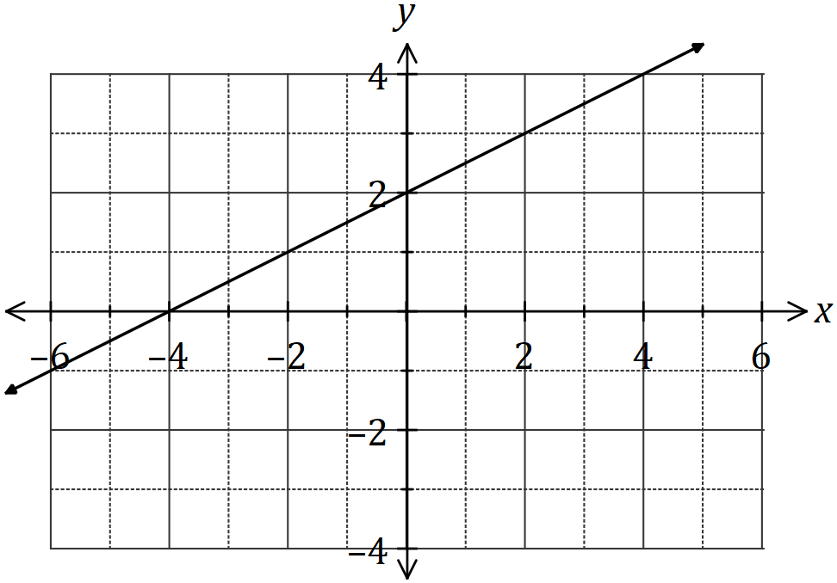

(b) Draw the graph of the line $y=3x+6$ on the axes below. (3 marks)

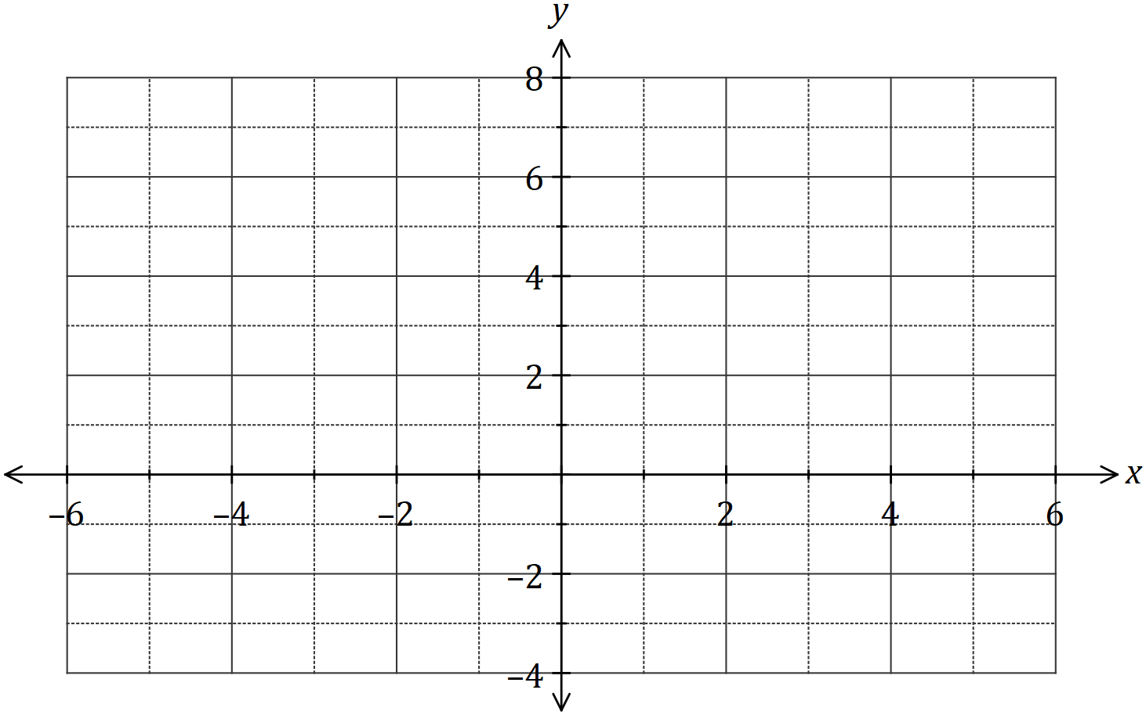

(c) Determine the gradient of the line $4x+3y=21$. (2 marks)

Question 4 (8 marks)
(a) The power $P$ consumed by a device can be calculated using the formula $P=I^{2}R-\sqrt{2I}$.

Calculate the value of $P$ when

(i) $I=8$ and $R=2$. (2 marks)

(ii) $I=0.5$ and $R=40$. (2 marks)

(b) The variable $D$ is related to diameters $d_{1}, d_{2}$ and $d_{3}$ by the formula $D=\begin{matrix}4 \\ \overline{d_{1}-d_{2}}\end{matrix}+\begin{matrix}d_{3} \\ \overline{ 2 }\end{matrix}$.

Calculate the value of $D$ when

(i) $d_{1}=11$, $d_{2}=3$ and $d_{3}=12$. (2 marks)

(ii) $d_{1}=6.5$, $d_{2}=7$ and $d_{3}=21$. (2 marks)

Question 5 (6 marks)
Consider the matrices .

(a) Determine . (1 mark)

(b) State the size of the row matrix. (1 mark)

(c) Calculate, where is the identity matrix. (2 marks)

(d) i) Calculate 2A (2 marks)

ii) Determine the values of if

Question 6 (7 marks)
(a) The lines with equations $2y+2=x$ and $x+y=9$ are shown on the axes below.

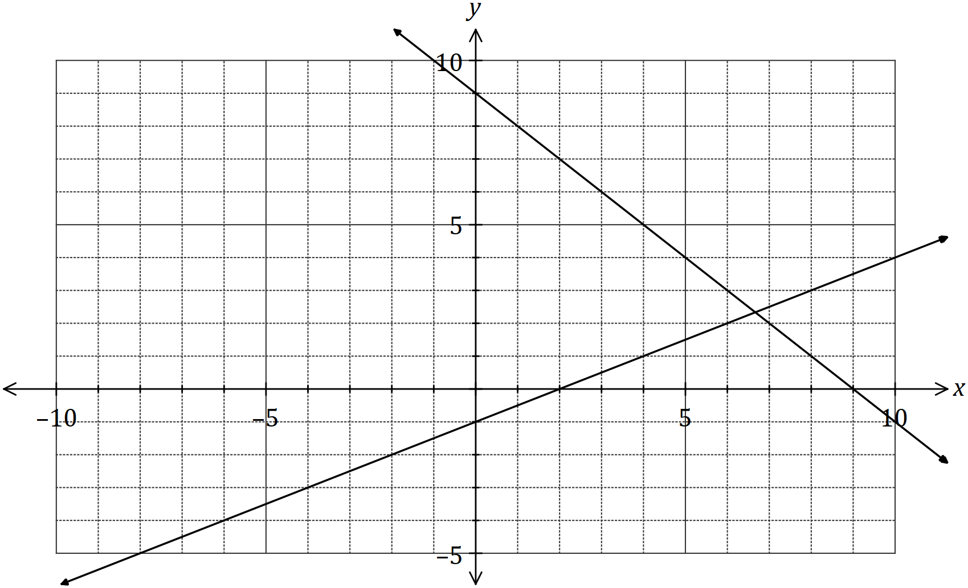

(i) Draw the line $y=x+3$ on the axes above. (2 marks)

(ii) Solve the simultaneous equations $y=x+3$ and $2y+2=x$. (2 marks)

(b) Solve the simultaneous equations $y=x+10$ and $2y-x=-2$. (3 marks)

Question 7 (6 marks)
The heights of $9$-year old girls are normally distributed with a mean of $133 \text{cm}$ and a standard deviation of $5 \text{cm}$.

(a) Use the $68\%, 95\%, 99.7\%$ rule to determine the approximate percentage of $9$-year old girls that can be expected to have heights between

(i) $128$ and $138 \text{cm}$. (2 marks)

(ii) $123$ and $133 \text{cm}$. (2 marks)

(b) Nurses at a health clinic measure the heights of children and refer anyone with a height that is more than three standard deviations from the mean of the child's age group to a doctor.

The last ten girls, aged $9$, who attended the clinic had the following heights:

$$119 121 136 140 125 135 142 123 117 136 \text{cm}.$$

Determine, with justification, how many of these girls were referred. (2 marks)

Question 8 (8 marks)
A group of friends who frequently travelled abroad exchanged foreign currency between themselves using the conversion table below.

The following trades were made using this table : $100$ dollars were exchanged for $20$ dinars
and $50$ kroner were exchanged for $10$ dollars.

Country/Currency | Australian/Dollar
 | $$10$$ | $$20$$ | $$50$$ | $$100$$
Denmark/Krone | $$50$$ | $$100$$ | $$250$$ | $$500$$
Japan/Yen | $$800$$ | $$1 600$$ | $$4 000$$ | $$8 000$$
Kuwait/Dinar | $$2$$ | $$4$$ | $$10$$ | $$20$$
Thailand/Baht | $$250$$ | $$500$$ | $$1 250$$ | $$2 500$$

(a) How many baht can be exchanged for $30$ dollars? (1 mark)

(b) How many dollars can be exchanged for $20 000$ yen? (2 marks)

(c) Before travelling to Kuwait, one of the group exchanged $490$ dollars for the local currency. How many dinars did they receive? (2 marks)

(d) Another member of the group exchanged $500$ dollars for a mixture of $1 350$ kroner and some yen. Determine the amount of Japanese currency they received. (3 marks)

Supplementary page

Question number: _________

